**Milestone 2**

**Team Unicorn Frappuccino:**

**Smart Shopping Planner App**

Lucas Sherman

Kunal Saxena

Raymond Wang

Bradley Schultz

1. Our team decided to use a survey as our primary research method as well as observations to further back up any findings. We decided on a survey because it is much easier to gather a larger set of data than it is by interviewing, although maybe not as in depth. This in turn will save us time allowing us to spend more time reviewing the data and designing the best possible interface. Most of us were not comfortable doing interviews. Some of us have done large surveys before in other applications (academic and otherwise), so we wanted to leverage that past experience. We felt keeping our survey to 10 questions would make it so that people don’t get intimidated right away and leave the survey. We found that since we only have 4 group members and since our project is small in scale, that we lack the manpower to effectively gather and analyze data from multiple sources, so triangulation wasn’t as necessary or possible.
2. Our survey is complete and can be viewed here:

<https://goo.gl/forms/W5JNcPePxfrWXYWB3> (Updated)

1. (Survey method): As of right now, we have received 26 responses to our survey. Our preliminary findings are as follows for demographics:

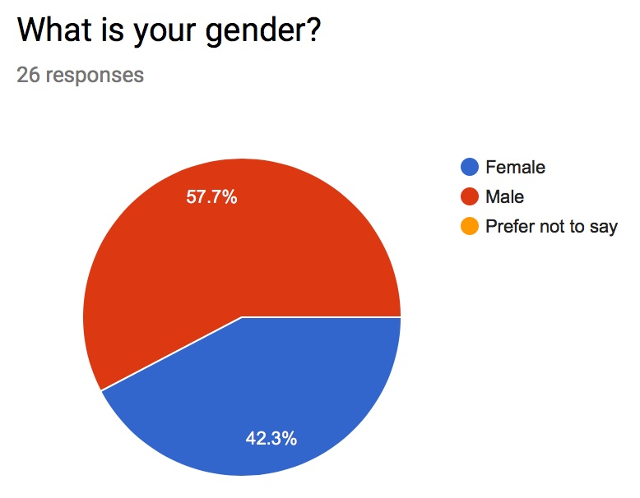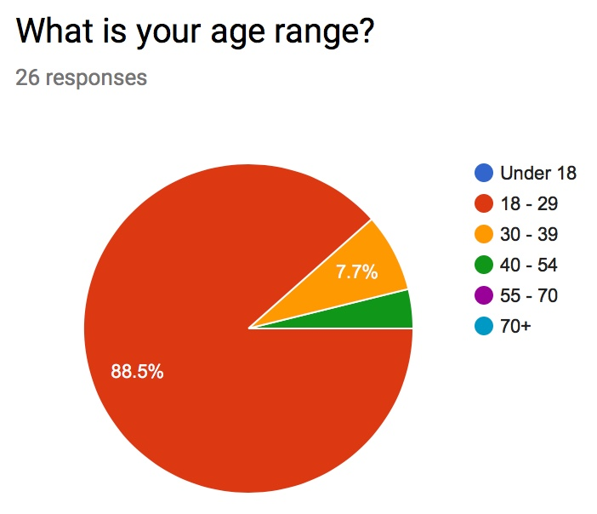

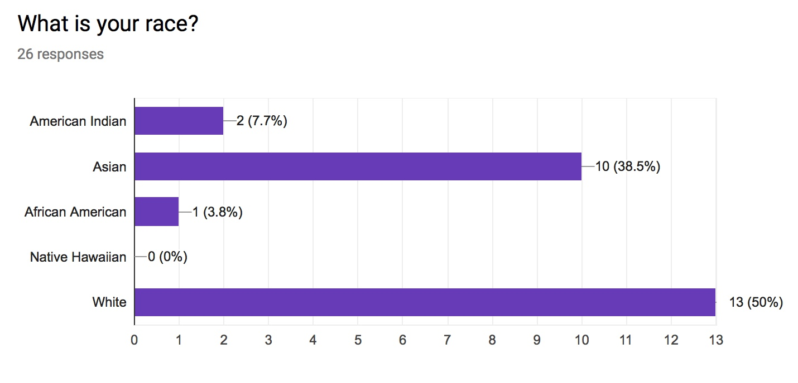

▲The majority of our participants are aged 18-29 and fall under the Asian and White categories.

Our preliminary findings concerning shopping are as follows:

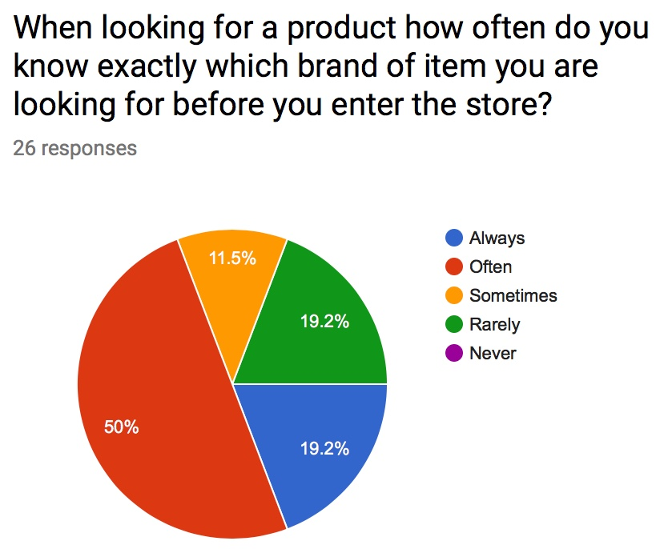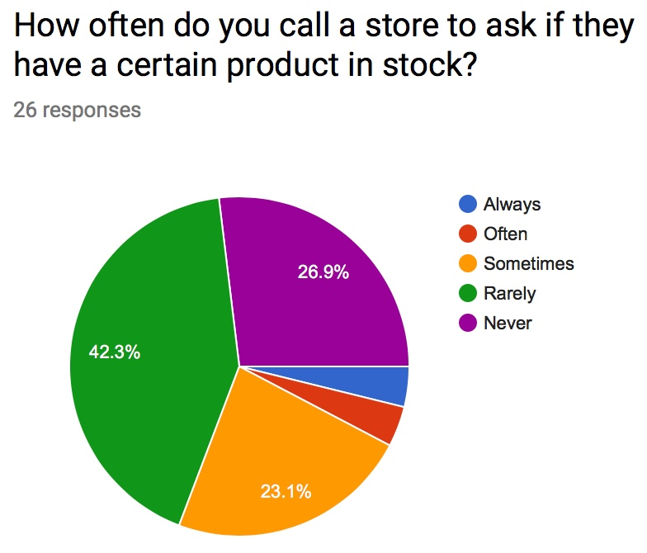

▲Half of the participants often know exactly which brand of item they are looking for before they enter the store. And so far, we have no participants that never know.

▲Over 40% of the participants rarely call a store to check stock availability for a certain product. And over one fourth of participants never do that.

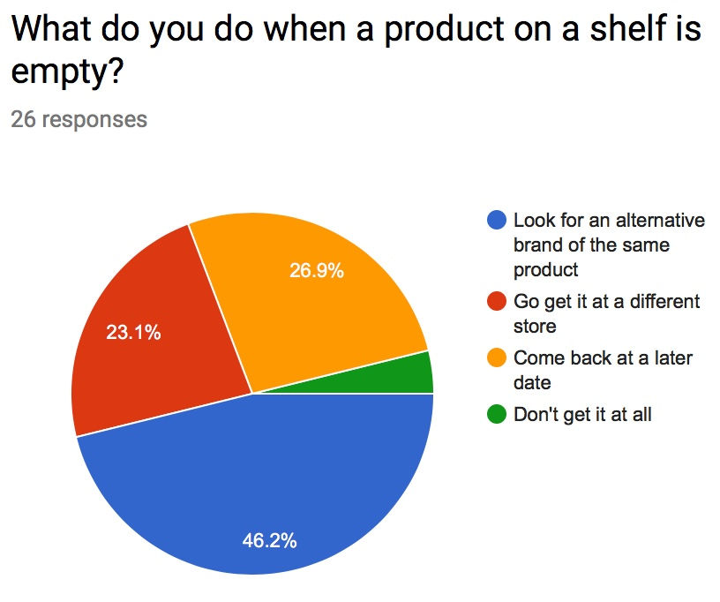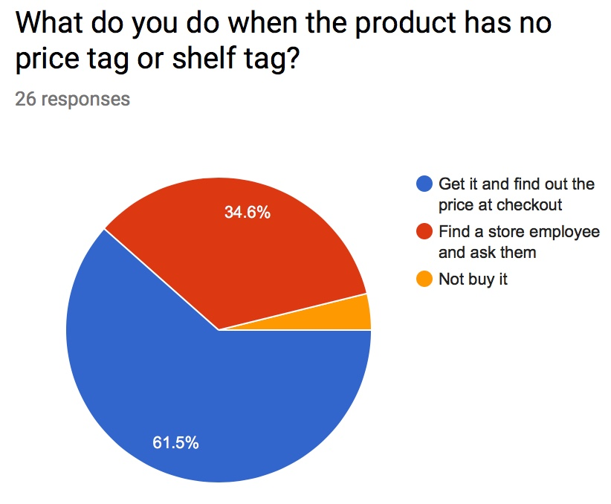

▲Almost a half of the participants would look for an alternative brand of the same product when a product on a shelf is empty, and over a quarter of them would come back for this product at a later date.

▲More than half of the participants take a product to the checkout when the product has no price tag or shelf tag and only a small fraction wouldn’t buy it.

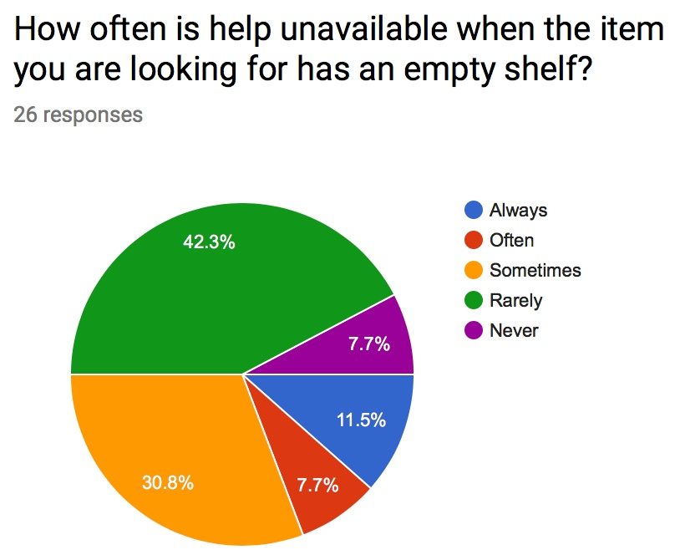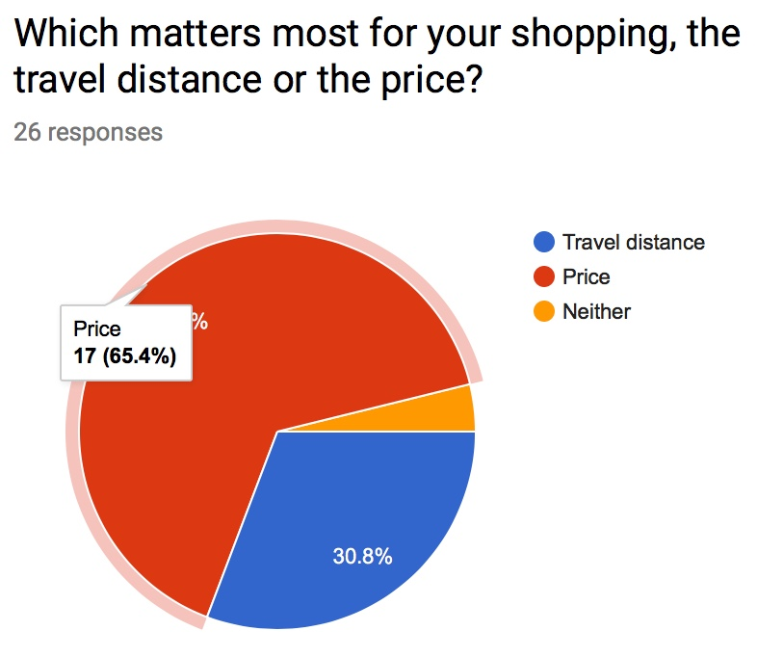

▲Over 40% of the participants would rarely looking for help when they are at the empty shelf, comparing with 30% of the participants would ask for help from store assistants.

▲For over half of participants, price matters the most, and for roughly one third of participants, travel distance matters the most.

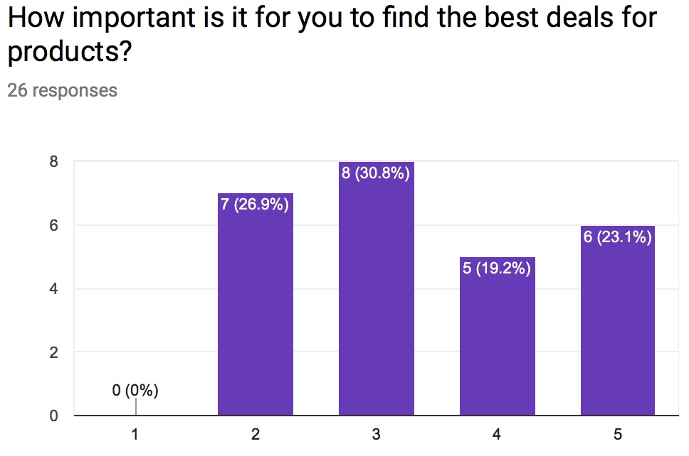

▲For finding the best deals for products, the results were more varied. Nobody responded that deals weren’t important to them at all. The results were mostly even amongst the other categories of importance, with values between about 20% to 30% each.

Lucas’s personal experience (Observations method):

While observing customers in a Staples office supply store it was noticed that most customers that want a product on a empty shelf tend to waste much of their time. The customer must first find an associate then get that associate to check stock for that product, where the associate must go down to that aisle and find the missing product shelf tag to get the SKU number. Then the associate must head back up to the front of the store to check product quantities. This could all be bypassed as the customer using the barcode scanning app to check product quantity themselves and only leaving the associate the task of finding the product based off knowing how many products are in store quantity.

1. See below. (Updated)

**Persona and Scenario 1**

Persona (Updated)

Bob, 25, lives in Vancouver, BC. Bob is a model and is very conscious about his skin. He only uses certain cosmetic brands in order to maintain his unique outlook and physical beauty. He maintains his outlook by tanning, going to the gym, and running, and the rest of his day is for his photoshoots. Since Bob encounters fans quite often, he doesn’t like shopping store to store, and would like to finish shopping as soon as possible. He would like a way to confirm whether his unique cosmetic products are in stock.

Scenario (Updated)

Bob goes to the store to buy some Dove brand soap. When he gets to the store, there is an empty shelf where the product is supposed to be. There are no store assistants around, but the price tag and barcode are on the empty shelf. Bob opens the Smart Shopping Planner App on his smartphone to scan the barcode. He sees the current store still has some Dove brand soap in stock. He goes to the help counter to get some assistance in finding the product.

**Persona and Scenario 2**

Persona (Updated)

Frank, 34, lives in Kelowna, BC. Frank is a bargain shopper who loves to get the best deals, especially on high value items. He loves to brag to his friends about the price of the latest tech that he’s bought. He knows his local stores very well and regularly keeps tabs on price fluctuations. Frank could also use online retailers to get even better prices, however he has had his email account login details stolen in the past, so he is now very wary of entering sensitive information on the internet, and will refrain from doing so whenever possible.

Scenario (Updated)

Frank is looking for some AA batteries for his new TV remote, since it never came with any in the packaging. He wants to get them at the lowest possible price quickly, since he can’t control his TV effectively otherwise. He abandons the idea of searching through multiple flyers and comparing prices, and instead he opens the Smart Shopping Planner App on his smartphone. He then searches for “AA batteries” on the app using the search tool. He chooses Duracell brand batteries and finds that an 4 pack of AA Duracell batteries is on sale at his local Walmart, with the lowest price overall at the moment. Frank begins to go to Walmart after he checks the desired product is in stock.